|  |  |
| --- | --- |
| **Canon PowerShot G7 X Mark III**  Máy ảnh Canon PowerShot G7 X Mark III (Black)  PowerShot G7 X Mark III  PowerShot G7 X Mark III 1 PowerShot G7 X Mark III 3 PowerShot G7 X Mark III 4 | **Featured information:**   * 4.2x optical zoom (24mm - 100mm) * 4K Video (no crop) * DIGIC 8 &; 1.0 inch Stacked CMOS Sensor * Livestream support   Price: 800$  **Specifications:**   * **Sensor Format:** N/A * **Resolution:** Actual: 20.9 Megapixel / Effective: 20.1 Megapixel * **Size photo:** 5472 x 3648 * **Image Proportions:** 1:1, 3:2, 4:3, 16:9 * **Sensor Type:** CMOS * **Image Format:** JPEG, Raw * **Anti-Vibration:** Optical * **Lens Mount:** N/A |

**Description:**

#### **20.2MP stacked CMOS sensor & DIGIC 8 processor**

The large 1' 20.2MP stacked CMOS sensor combined with the DIGIC 8 image processor on the G7

#### **Design of Canon PowerShot G7 X Mark III Camera**

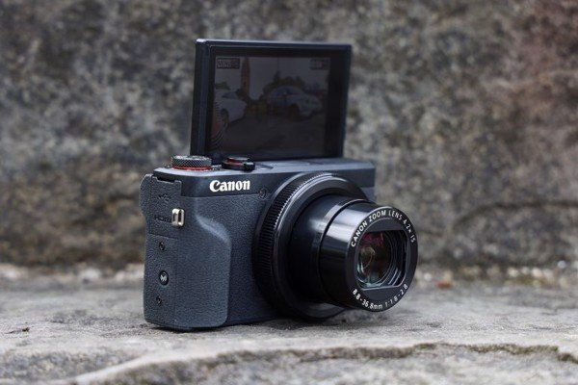

The PowerShot G7 X Mark III camera is a compact camera belonging to Canon's G-series line. With a weight of only 304g combined with two main color tones of black and silver, the G7 X Mark III is the right choice for those looking for a compact camera with a luxurious design. G7

